Description: A21 Logo_Black_Tag

# POS STock Receipts process

Selecting/Loading transactions

1. Select Stock Receipts menu option from the File menu
2. Sign on using the sales person login
3. To check for any incoming transfers, press <F6 Transfer Search>. To check for any incoming purchase orders, press <F4 Purch Order Search>. If there is only one incoming receipt, the details will load into the screen. If there are multiple transactions, a selection screen will display. Choose the required transaction and click the OK button to load the details into the screen.

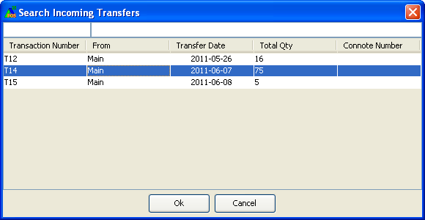

1. Or, if you know the relevant number, you can enter this into the scan field (preceding with ‘t’ for transfer or ‘p’ for purchase order) or scan the barcode printed on the paperwork attached to the goods (if transfer is from another store).

*For example if receipting transfer 123 then you can type in T123 . Then press <ENTER>.  This will search for the transfer details and populate the screen with the transfer number, the departure point of the goods and the detail of the items. If the transfer cannot be found or was due for another store, a message is displayed. If a message displays that some items on the transfer are not valid for the store, contact Head Office.*

## Receipting quantities

There are several ways to receipt in stock quantities.

1. Place the focus / cursor at the entry point and individually scan each item received. This is the recommended option if items are not delivered with carton labels.

*The Quantity received field is updated.*

***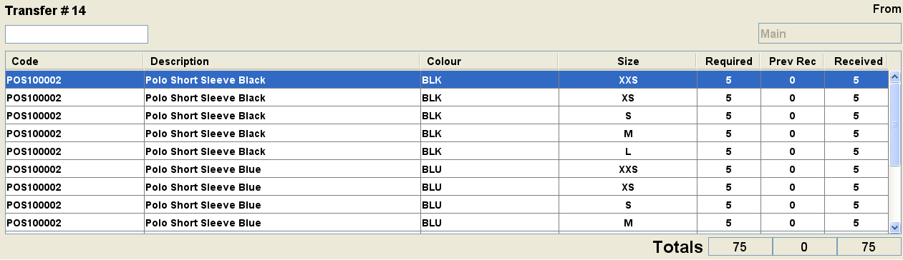***

***Received quantity is updated***

1. If you cannot scan then type received quantities into the *Received* column (not as accurate as scanning) or the standard search function <F12> can be used.
2. After physically checking the stock against delivery documentation, use the <F8> Receipt All option. This will update the *Received* column to equal the same value as the *Required* (i.e. sent) quantity. Any discrepancies found during the physical check should then be adjusted. Security is required to use this feature.
3. Use the <Alt+I Import> button to scan in SSCC carton labels (only for deliveries from internal warehouses) or import scanned carton/item barcodes from a file.

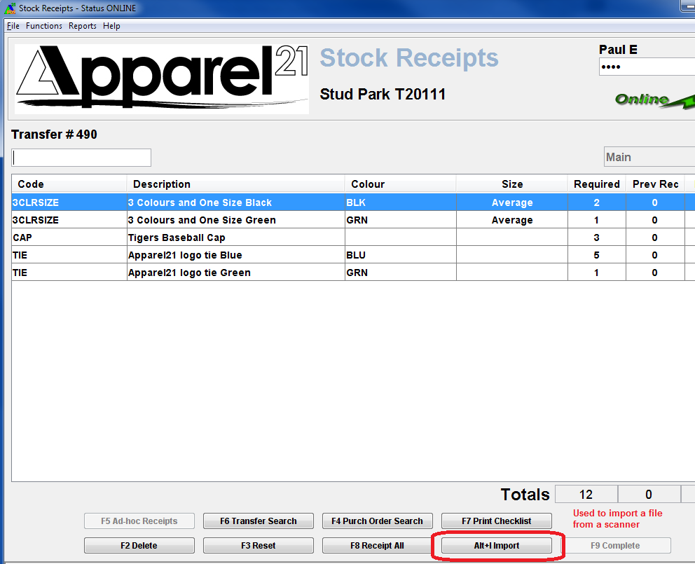

The following screen will appear:

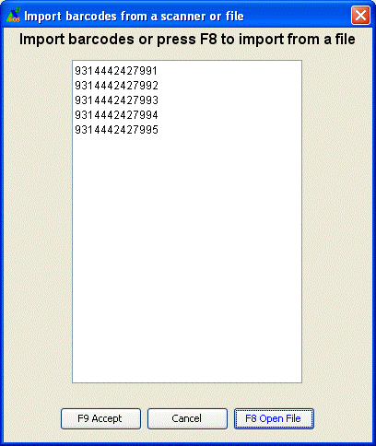

Either scan carton labels into this popup or, if using an offline scanner, select <F8 Open File> to browse to saved file location the click <Open> to load details.

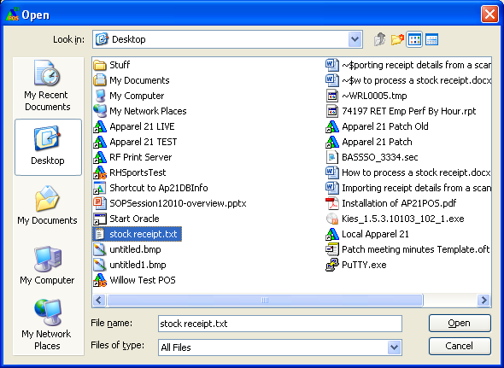

Offline scanners must be programmed to store a single line per barcode, include the check digit and have a carriage return.

1. When all product quantities have been scanned / entered, use <F9 Complete> to finalise the transaction.
2. *The Stock Receipt docket is printed.*

Additional Information

* You will only be able to receipt items that were not on the original transfer/order if security is enabled for this. There is also security to control whether over receipting of quantities is allowed.
* Where an item is receipted that was not on the order, a new line is displayed with a 0 quantity in the *Required* column and a value in the *Received* column.
* Even after the <F9 Complete> button has been used and docket printed, if any line still has an unreceipted quantity then this transaction will continue to display in the transfer/purchase order search screens. This is to allow users to update the transaction if items are found later. This will continue to display until either all quantities are receipted at store or HO has finalised the transaction via the Stock Transfer Maintenance screen.