Description: A21 Logo_Black_Tag

# POS return/refund process

If a customer returns some goods, the sales staff are prompted to select a reason for the return.  If the customer has the original docket, the barcode on the docket can be scanned to recall the original sale.  If a return must be processed on the original docket, this can be searched for.

1. Position the cursor in the entry field
2. Scan the barcode printed on the docket of the original sale (or search for sale via History Lookup).
3. This will retrieve the sale and display the details on the screen.  If the barcode can’t be scanned, the barcode number can be manually entered.
4. Use the mouse or arrow keys to select the item/s which are returned, click on the line/s to highlight them. (Hold down CTRL key to choose multiples)
5. <F7> to process return and user is prompted to select a Return Reason.
6. Choose a reason using the mouse or the Arrow <⬆>, <⬇> .  Extra text can be entered in the field below if required.

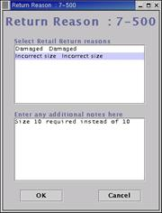

1. Use the <Enter> key or the mouse to click on the <OK> button to validate and go back to the sale screen. The quantity of the goods will have been changed to negative and any items not being returned will be removed from the screen.
2. Scan in replacement items if this is an exchange.
3. Use the <F9> Payment function key to process the refund/exchange.

(At this point, if head office have set up that a retail customer must be linked to a return, the person maintenance window will open. A person must be attached to the return transaction to move on to the payment screen.)

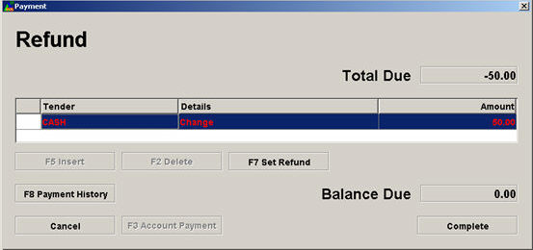

1. You can hit <F8> key to view the payment history of the original sale.
2. The <F7 Set Refund> button is used if you want to specify the refund method other than the default tender for this particular refund. Applicable refund tenders are set at the back office.
3. The <F4 Refund Override> button is only available for a user who has security. It is used to specify the refund tender regardless of what has been set up at the back office.
4. If a credit note is used to refund the customer, a credit note docket will print after the return docket.
5. If the customer does not return the docket, simply scan the barcode of the items returned, and then follow the procedures beginning from step 3.  Normally only credit note will be available as the refund tender unless you have security to override. The Search <F12> function can also be used to search for styles.