Description: A21 Logo_Black_Tag

# POS sales processes

How to process a sale

1. Log in using the sales person sign-on code and password
2. Scan the product barcode OR search for the product code using  <F12>
3. Repeat point 2 for all products purchased
4. <F9> to display payment screen
5. The "Tender Type" dialog displays, select a tender (payment method)

A tender can be selected by several different methods.

* Key the first letter of the tender to select it (i.e. C for Cash)
* Use the Arrow up and Down to select a tender
* Use the mouse

1. Enter the payment amount and press <Enter> key on your keyboard. Or click <OK>

* The total remaining due amount will default into the amount due field. You may override this if there is going to be more than one payment method (tender).

1. If several payment methods are used, repeat steps 5 and 6 until the due amount is 0.

At this point the Complete button is activated.

1. (Optional) F4 to Print customer address details, if they are required for claiming tax.
2. Check the screen for any change due to the customer and click the <Complete> button or hit <F9> to complete the sale.

The cash drawer will open (depends on the tender type) and the docket will print.

How to apply a discount

Discounts can be given to customers for each individual item purchased or for a whole transaction.  A discount reason needs to be provided.  Discount reasons are defined by head office and preset to a discount percentage.

1. Add products to the sale as per normal
2. Select product lines that discount is to be applied to (if discount is not for whole transaction)
3. Select <F4> to apply discount

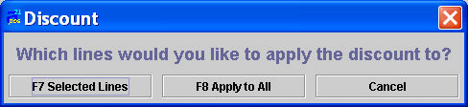

1. Select <F7> to restrict discount to only the selected lines or <F8> if the discount is to be applied to the whole sale
2. Select the discount type / reason and OK

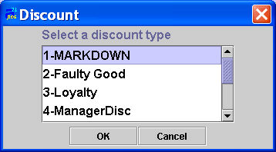

Depending on the type of discount selected, the screen will display the option to enter a discount %, a new price or a discount $ (or all three).  This is controlled by the head office rules that have been entered.  Also attached to each discount code is a restriction to the maximum amount of discount that can be applied.

1. Enter the discount %, Amount (to be taken off price) or New Price $ and OK

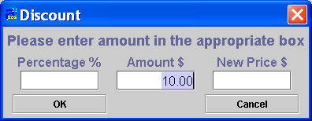

A new line is displayed below the product line or each product line where the discount was applied to the whole sale.  This line shows the discount amount and the reason for discount..

Note:  If the user has manager security level, the manager discount reason can be used and the discount percentage or amount can be overridden. To do so, use the tab key or the mouse to click on the Percentage field or on the discount amount field and key in the desired value.

How to attach a customer to a sale

1. Enter a sale transaction as described in How to process a simple sale from step 1 to 3
2. Before proceeding to the payment screen use <Alt+C>

Apparel 21 can configure the system so that the system will prompt for customer to be attached to a sale transaction when proceeding to the payment screen

1. Person screen will be displayed
2. Enter customer details
3. <F9> to accept details
4. <F9> Payment to proceed to complete the sale transaction
5. Enter payment details
6. <F4> in final screen if customer address details are required to print on the docket

How to hold a sale

This function allows for sales to be held and processed at a future time and date.

1. Log in using the sales person sign-on code and password
2. Scan the product barcode OR search for the product code using  <F12>

Note: See above for more details on how to use product search.

1. Repeat point 2 for all products purchased
2. <Alt+R> or use the mouse to select <Alt+R> Hold button

How to recall a sale

This function allows the user to recall held sales.

1. Log in using the  sales person sign-on code and password
2. <Alt+R> or use the mouse to select the <Alt+R Recall> button

This will display a list of all held transactions

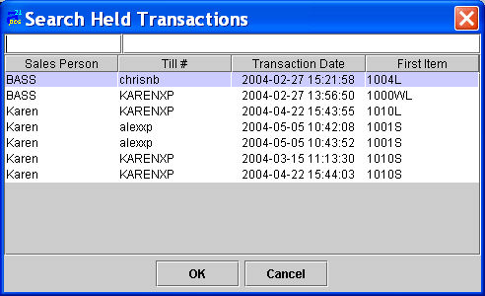

1. Use the search functions or the mouse to select the transaction that is to be completed

This will then re-display all the details of the transaction

1. Continue to process the sales as per normal

How to use Integrated EFTPOS

Users can split payments across cards when using integrated EFTPOS. Users will be able to select the tender multiple times just like any other payment type.

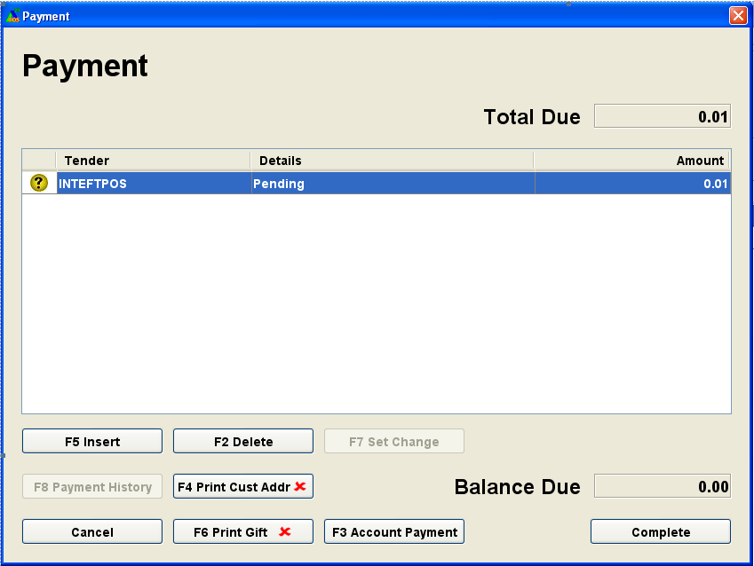

* Pressing <Enter> or selecting the <Complete> button once the "Balance Due" is 0.00 will start the EFTPOS processing.
* Swipe a card and respond to the prompts as usual.  After the first card transaction is approved, the user will be prompted to swipe the next card, and so on.
* The docket will print once the final card has been approved.
* If any card is declined, a message will display asking the user if they want to try again. This will enable the user to try to reprocess the card if ‘Yes’ is selected.  If ‘No’ is selected then the user can remove the declined card line with <F2 Delete> and add a different payment type with <F5 Insert>.

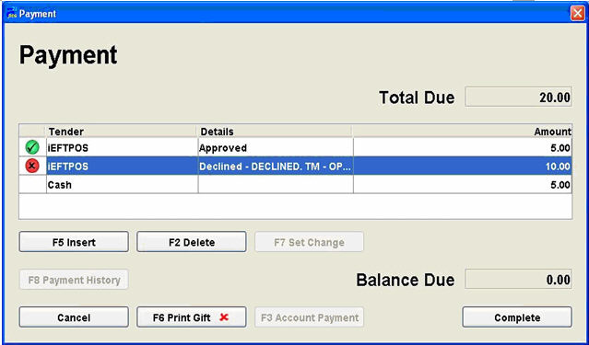

* If the customer does not wish to pay by a different method then use the <Cancel> button or press the <Esc> key to cancel the sale.  The user will be prompted to swipe any card/s that have already processed so that the bank transactions can be reversed.
* Please note: Refunds can only go back on one card when using integrated EFTPOS.