Description: A21 Logo_Black_Tag

# POS Gift Voucher

## Voucher Sales

To Sell a Gift Voucher through the POS, the voucher product needs to be added to the Sale. This can be done through a barcode assigned to the product, or via the product lookup.

Scan in the voucher product.

The system will prompt to enter a voucher number.

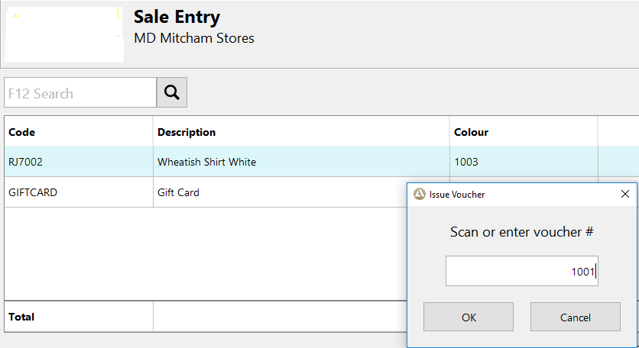

The number will be visible in the physical voucher that is being sold to the customer.

Enter the number found on the voucher.

The voucher will now be visible in the sales screen as a sale line. A value will need to be added to the product. Without a value being entered, the voucher will have no value.

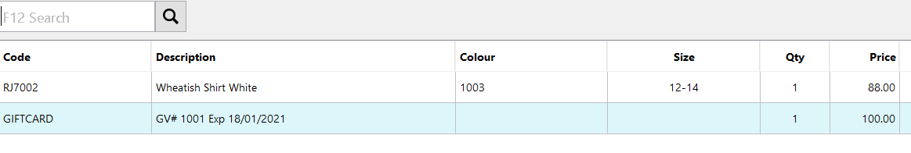

## voucher redemption

Apparel21 will allow gift vouchers and promotional vouchers to be used as tender when shopping online using the Retail API as well as in stores or via Mail Order. The POS payments screen has also been modified to allow for a PIN to be entered for *secure* vouchers.

### Exclusions

The following limitations apply to the redemption of vouchers

* Vouchers can only be redeemed if they were issued from Apparel21
* Promotional vouchers cannot be redeemed when the number range has been suspended
* A promotional voucher can only be used once – no value will remain on the card if it is unspent.

### Redeeming vouchers at POS

When choosing Gift Voucher as a payment type at POS, the system will first prompt to enter the voucher number. (This can be scanned in if a barcode is available on the voucher, or entered manually)

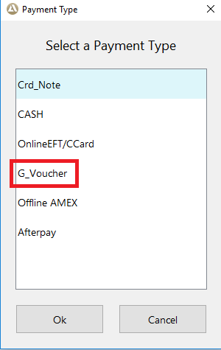

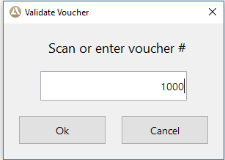

If the voucher number entered is not correct, or not valid for the store then an error will be produced.

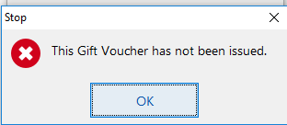

If the voucher that was entered is valid and is a secure voucher, then the operator will be prompted to enter a PIN.

Enter PIN and click ‘OK’

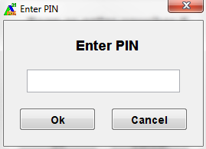

If the PIN entered is incorrect then:

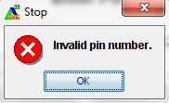

If the voucher is not secured, or the voucher has been deemed valid after entry of the PIN, the operator will be show the current available balance on the gift voucher to be used.

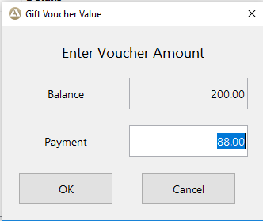

The operator needs to confirm the amount of the payment to apply to the sale. The full amount of the voucher can be used to pay for the sale or part of the balance can be used as part of the payment for the sale. If the amount entered for the payment is not enough to cover the total value of the sale, the operator will be prompted for another payment method for the remainder of the unpaid portion of the balance.

Once the voucher payment has been added to the sale, the voucher payment details can be viewed in the payment confirmation screen

If the Gift voucher has been used previously the following message will be shown

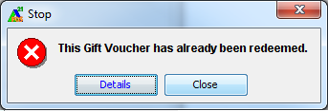

Selecting the *Details* button will display the zero value on the voucher and when it was last redeemed.

## Gift Voucher Balance Enquiry

When a customer presents a gift card, the operator can check the balance.

Log in to POS >> Functions >> Gift Voucher Balance Enquiry

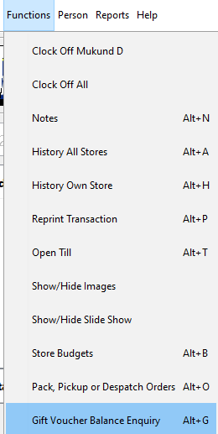

Scan or enter the gift card number >> OK

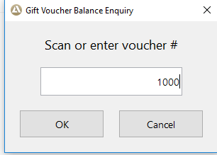

The operator is presented with the folliwng screen.

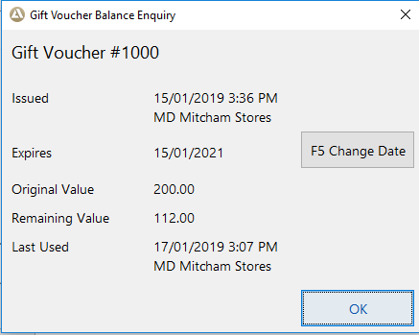

## promotional voucher balance enquiry

Promotional Vouchers are not sold. They are loaded with a presetermined value.

In order to find out a balance on a gift voucher click on Functions>> Gift Voucher Balance Enquiry



Scan or enter the voucher number >> OK

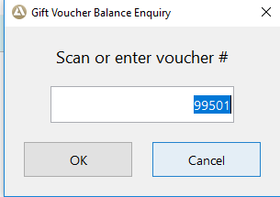

The folliwng information is displayed.

