Stock Reserving for Write off or Shop soiled:
If you have an item in store that needs to be either written off or is shop soiled and keeps getting re-picked for Online, Please follow these steps

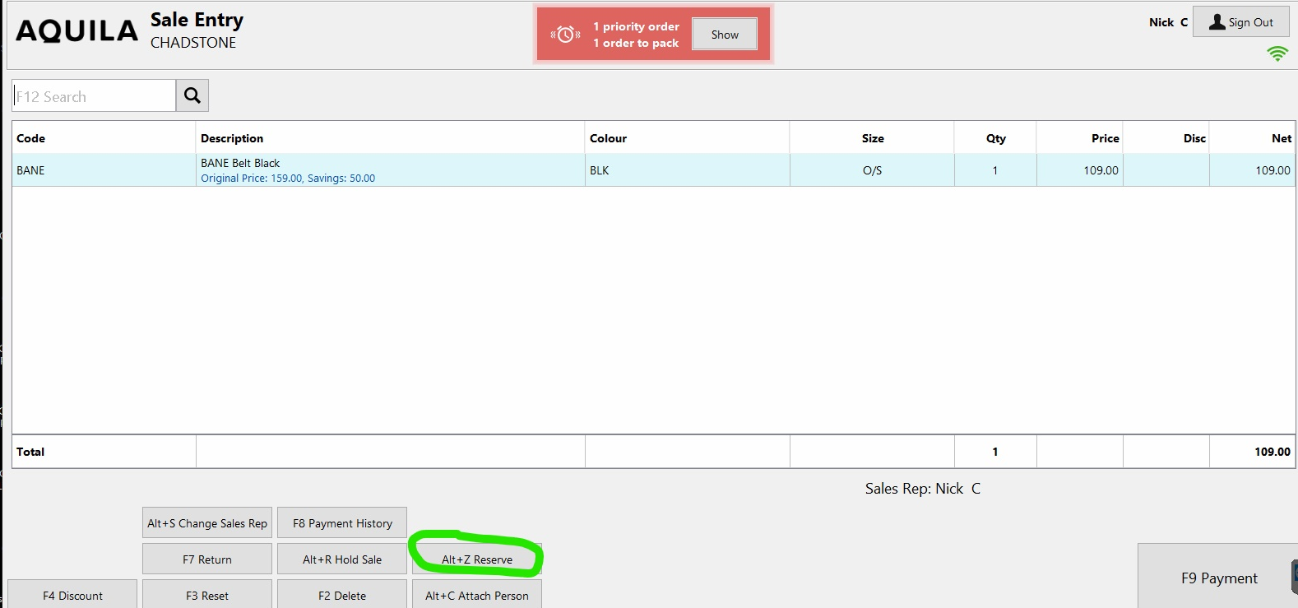
In sale entry find the item you need to reserve, then click Reserve (circled in green below)
You will then be prompted to Attach a customer, for this you will either choose
- Reservation Write off- if the item needs to be written off complete
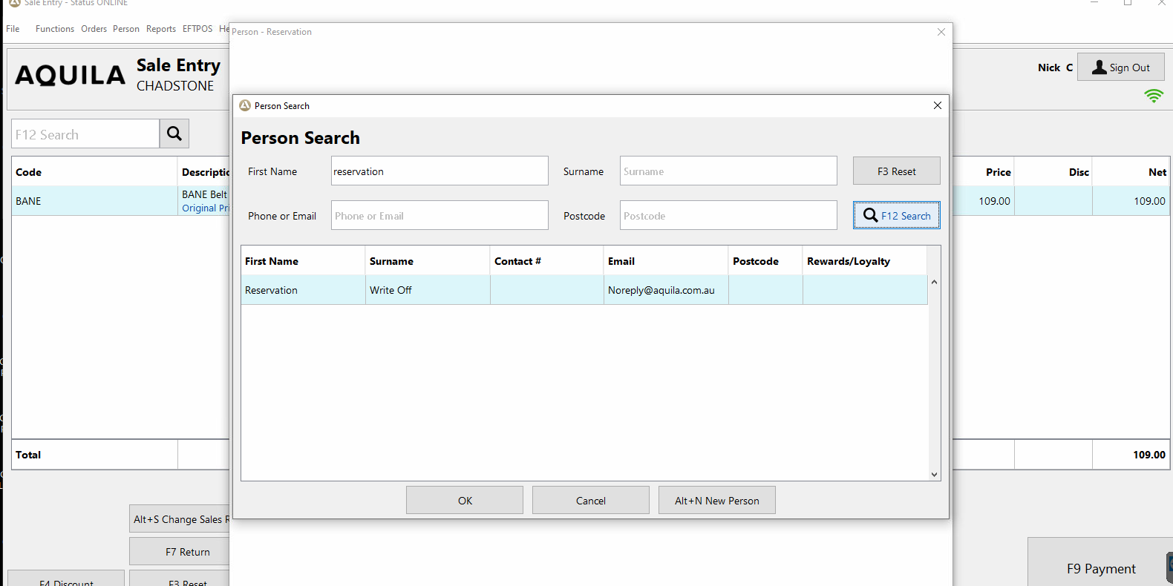
- Shop soiled- If the item needs to be taken off the system to avoid getting repicked for online sale
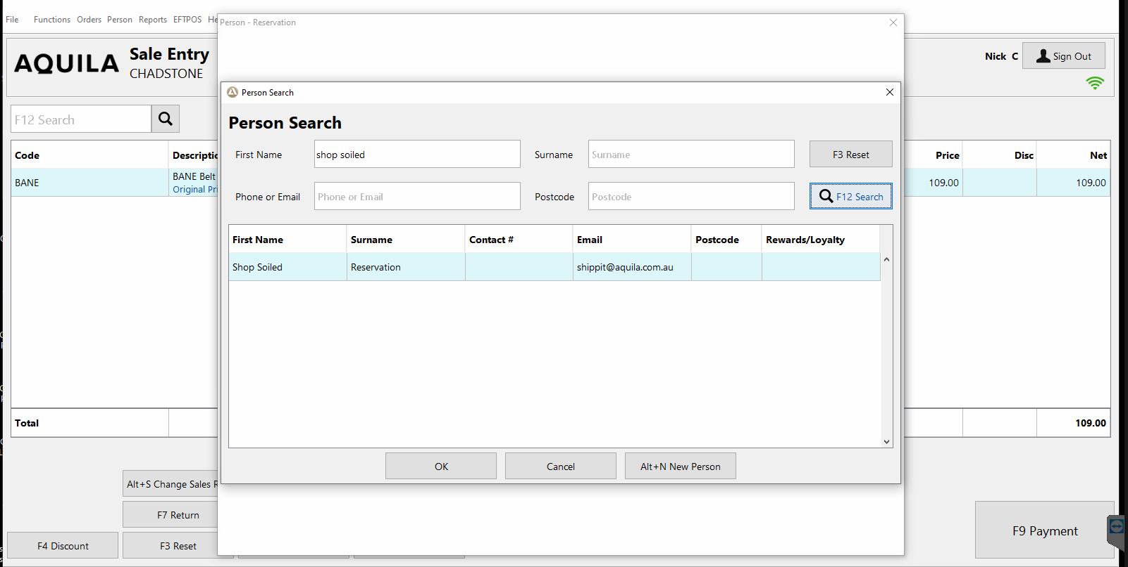
Choose the type of reservation (both in pictures above) Then simply attach the customer.

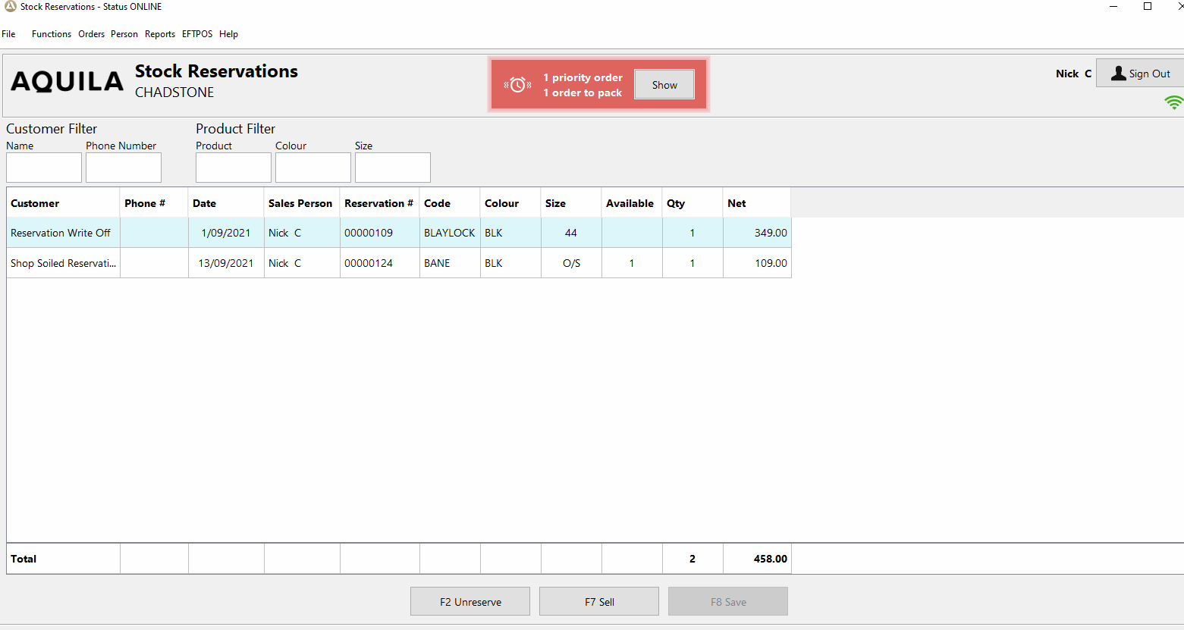
This will Now be in your Stock reservations. This is found under file on your POS

