Delivery labels – Unreadable / unscannable?

If you start to notice your labels aren’t printing clearly, please stop and read the steps below to fix the problem.

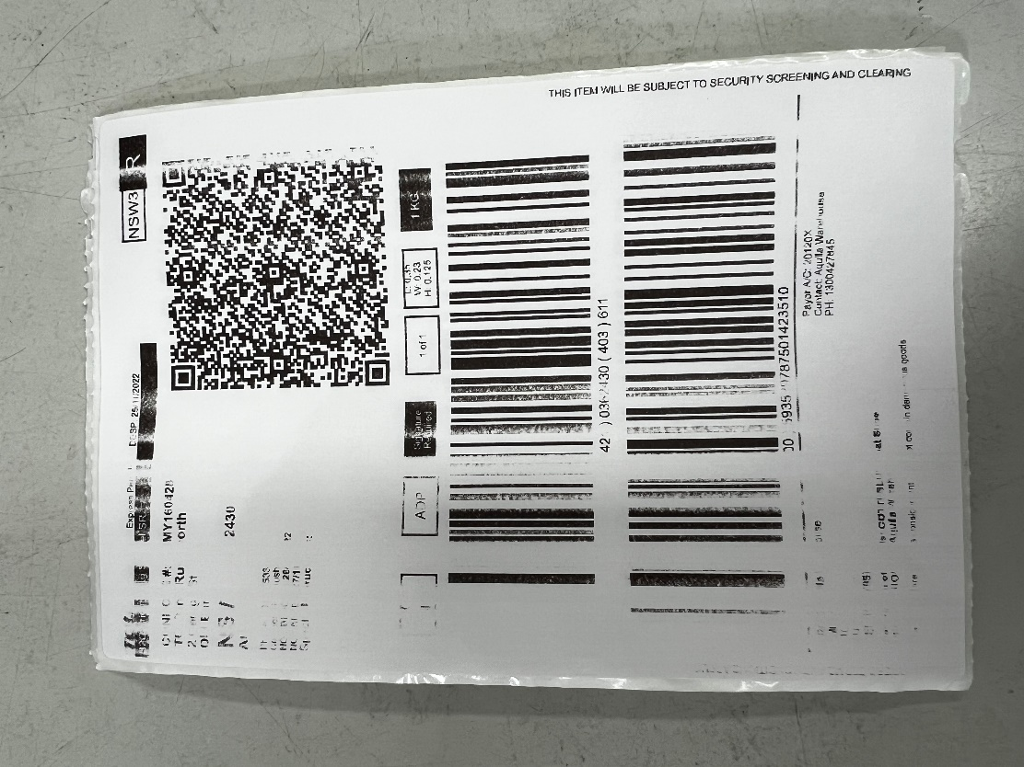

Step 1. Open the printer cover where the labels come out from the printer.

Step 2. Grab an anti-bacterial cleaning wipe and a paper towel.

Step 3. Clean the printer head using the anti-bacterial wipe (**Printer Head highlighted below**)

You will notice black hard bits, use to the wipe to scrub it off and then dry it with the paper towel.

Step 4. Close the printer cover and you can resume printing labels.

**You may need to press the pause button 1x time if no label comes out.

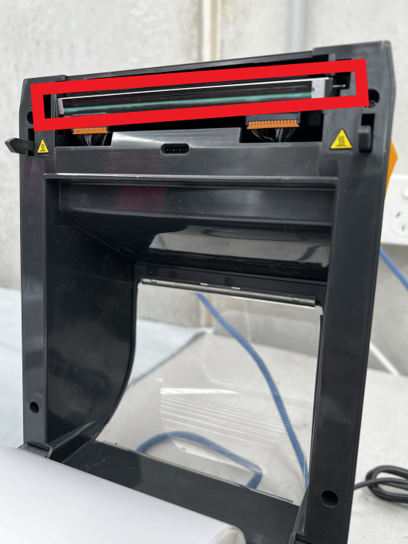

***If this does not resolve your issue, please call Aquila IT Support at 03 8412 9850  
Or send an email to [Support@aquila.com.au](mailto:Support@aquila.com.au)

Aquila IT Support documents can be found here: <https://storesupport.aquila.com.au/hc/en-au>